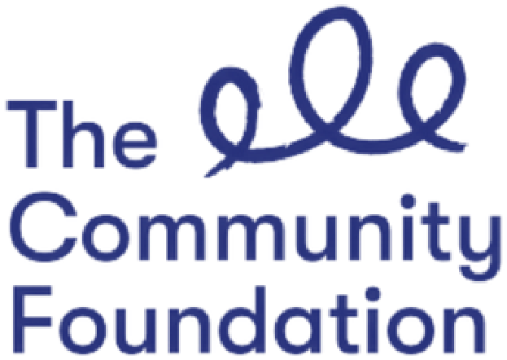
Application Pack

Your Place,
Your Voice.

The Move On Up bursary scheme is for young care leavers aged 16 to 25. The scheme provides financial help as well as practical support to help you take that next step in your life.
Who can apply?
If you can answer ‘yes’ to all of these questions, then you can apply to the scheme.
Have you lived in care?
Are you 16 – 25 years old?
Have limited or no financial support from leaving and aftercare services?
What can I get help with?
Help is available under three themes:
Enjoying, Learning & Achieving – Do you want help to get back into education or to learn a new skill? We can support you with course or exam fees, laptops, books and more. You may need help to get into the world of work. We can assist you to buy uniforms, equipment or tools or health and safety certifications etc. We can also support you with job applications and preparing for interviews.
Emotional Health and Wellbeing – We know it’s been a hard year for everyone so you might need support with your own emotional health and wellbeing. We can help you organise and book therapies, counselling, courses in yoga, online courses, cookery lessons, art or music therapy, gym membership, etc.
Inclusion and accessing new opportunities – Do you need help to get connected with your local area or to try something new? Maybe you need some help to keep in touch with the people or places important to you? This scheme could help you buy digital equipment to stay in touch with family and friends. If you are new to your area you might want to join some local classes, like developing a skill or learning a new language, even sign language. If you are new to Northern Ireland, that could include learning English. Perhaps you want to meet new people through a new hobby or interest? We can help you do that.

What support can I get?
- Up to *£500 bursary to help you to reach your goals
- A MADLUG bag and water bottle
- Coaching support with a member of the VOYPIC team to help you create an
action plan to achieve your goals
Ongoing support from a mentor who will help you put your plan into action
Priority access to other VOYPIC programmes, eg. peer support groups, advocacy support, weekly Participation Forums, and youth leadership programmes.
What is a mentor?
VOYPIC mentors are people in the community who have a passion for supporting young people and, as they are volunteers, they do not get paid. They will be someone that will meet with you and help you achieve your goals and provide you with support throughout your journey. All young people that are awarded the bursary will be matched to a volunteer mentor.
What if I don’t need that much money?
You may not need a mentor or a large amount of money to achieve your personal goals or ambitions. We offer a number of smaller bursaries (of up to £100) for smaller items. Some examples of these are short term gym classes, books for school, equipment for sports activities, accessories for your computer, short courses, etc.
Requests for this support must still meet one of the key themes outline above.
How do I apply?
To apply for the Move On Up bursary scheme, you must complete an application form. You can online or by post.
Online Application – to apply online, visit www.voypic.org/moveonup
Paper Application - complete the application form included in this pack and return it to: Move On Up VOYPIC
9 – 11 Botanic Avenue
Belfast, BT7 1JG
The closing date for applications is Friday 25 March. A panel, including young adults with experience of care, will meet the following week to review applications and people that have applied will be informed of their application status no later than the Friday 15 April.
Need help applying?
If you need help to complete the application or you want to talk about anything to do with the scheme, please email paul.mccafferty@voypic.org or call 07818236862.
*Bursaries will not be paid in cash. VOYPIC will purchase items directly on your behalf or reimburse expenses paid on production of receipts. In order to receive the bursary you must commit to being supported by a mentor to reach your goal.

Move On Up Application Form
If you have any questions about the scheme or this application form, please contact Paul at paul.mccafferty@voypic.org or call directly on 07818236862.
- Please provide the following contact information:
Name
Address
Town/City
Post code
Tel:
Email:

- What is your date of birth? DD/MMY/YYYY
- Are you care-experienced?
Yes No

- Are you receiving support from a leaving and after-care team or 16+ service?
Yes No

- Do you have a social worker?
Yes No

If you answered yes, please provide the following details for your social worker.
Name:
Team:
Contact number:

- Under which theme are you making an application to the scheme? Please tick the relevant box.
Enjoying, learning and achieving
Emotional health and wellbeing
Inclusion, accessing new opportunities
Please tell us what you want to achieve through the scheme.

- Which bursary are you applying for? Please tick the relevant box.
The bursary of up to £500 with mentor support.
The bursary of up to £100.
- How will you spend the bursary? Please provide a breakdown in the table below:
 | Item | Cost
EG(1) | Specific course (£189) & 3 specific books for course (£73) | £262
EG(2) | 10 guitar lessons (£250) & guitar (£150) | £400
EG(3) | Gym membership for year (£229) & gym clothes (£100) | £339
1
2
3
4
5
Total Cost |  | £

- How could a mentor help you? What type of help and support would you like from a mentor? (For example, help me find the right course; help build my confidence, help me get to know the local area, keep me motivated etc)

